SpiritBro Installation and Operations

Spirit Factory Electronics Version

Thank you for purchasing the A2ThreeD SpiritBro adapter kit! This kit will allow you to use a Hasbro 1984/Spengler wand to control your Spirit Life Size Proton Pack factory electronics (tested up to the end of 2024 packs, unsure of compatibility of 2025 revisions). We have additional versions that also allow the control of Frankengeek Electronics kits as well.

### Kit Contents

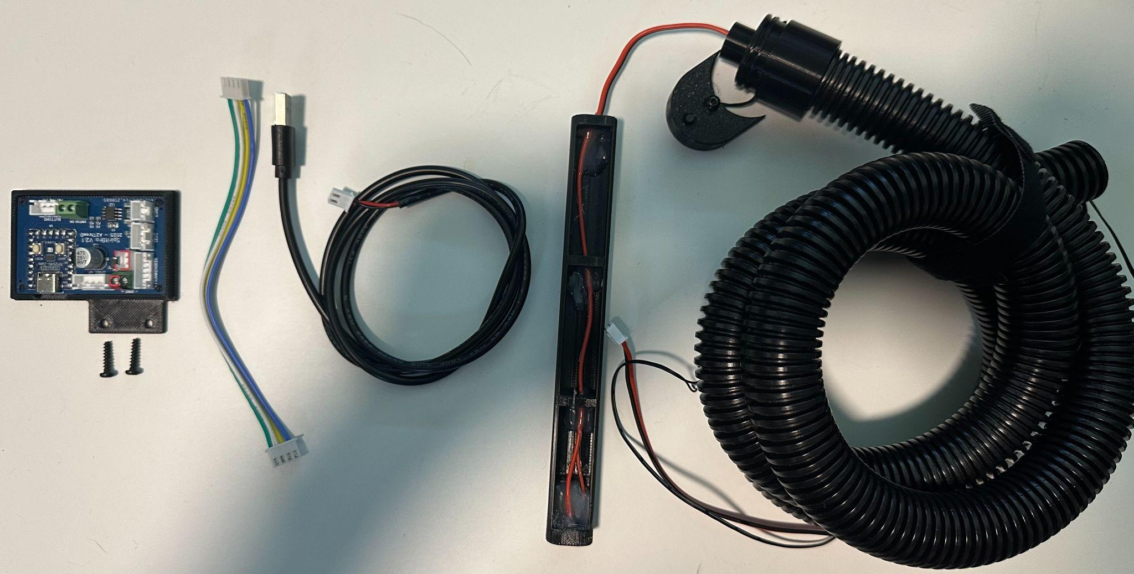

Depending on the version of the kit you ordered, you should have the following (from left to right): Spirit Bro board (revisions vary), interface cable, USB power cable, wand battery eliminator sled with hose/wiring and end-cap, and optionally a function button pod (attached to hose end cap).

### ESD Warning

The circuit board included in this kit contains sensitive electronics that may be damaged by electrostatic discharge (and stray proton streams!). It is best to handle this board by its edges or in the 3D printed carrier it is installed on. Only work on your pack/board when on a table and not a carpet or rug. You can additionally ground yourself by touching a metallic object before working with this kit.

### Preparation

In order to install this kit, you will need some basic tools and have to only modify/cut one wire. You will also need to provide a good regulated 5V USB power source like a battery bank. We recommend the Talentcell 3000mAh or 6000mAh batteries as they are a community tested favorite, and can be purchased on Amazon.com.

### Required Tools

* Screwdrivers - Philips and Flat-head in various sizes such as micro-drivers, hex bits and possibly star bits (for pack screws, Spiritbro electronics screws and button box screws)
* Wire cutters
* Wire strippers
* Heatgun or Hairdryer

### Important Warnings

This kit MUST run on a 5V power source. If you attempt to power it with higher voltages (TalentCells have a 12V barrel plug) you may damage or destroy this kit, your factory electronics and Hasbro wand. We are not responsible for any damage to your equipment or person due to the use of improper voltage, or reversed/shorted wiring. Always be sure any connections you make are clean and secure with no frayed or strands of wire sticking out or touching other wires.

### Installation

Be sure to check out our installation video here!

### 

#### Removing Back of Spirit Pack

Remove the back of the Spirit Life-Size proton pack. This may vary based on modifications that you have done to the pack (like a new motherboard, frame, etc.) At the simplest stock configuration, you will need to remove the black back padding. After that you have to remove the back panel (motherboard) by unscrewing it. There are six screws total you will need to remove located on the top, sides and bottom. The original motherboard is also secured with hot glue that may require a hair dryer or heat gun to soften the glue.

#### Battery Pack Removal

Remove the AA batteries from the original battery pack. Clip the red/black leads of the battery pack about 6-8” above the Spirit factory electronics board. Be very careful as the wires are brittle and can come removed from the factory circuit board easily. Carefully strip the insulation off the ends of the original wires about ¼” back.

#### Original Wand Removal

Unplug the 4-pin (JST-XH) connector that comes into the pack from the wand hose from the original circuit board. Unscrew the wand hose retaining screw from the hose on the lower right of the pack. You will also have to remove some hot glue to remove the wire. Remove the factory hose/wiring by gently pulling it out of the pack.

#### 

#### Installing the SpiritBro Board

The image following this will show how you make all of the connections. The board shown is V2.1.

#### 

**Spirit Electronics Power Connection**  
Attach the Spirit factory circuit board’s power wires that you prepared to the Spirit Bro board’s green terminals on the top of the board labeled - SPIRIT +. This is done by using a small flathead screwdriver to unscrew the terminals to open them. Pay close attention to the polarity. ***Make absolutely sure*** the black wire goes into the left terminal labelled - and the red goes in terminal labelled +. Reversing these OR leaving bits of the wires sticking out may cause shorting or damage to your board. Verify the connections, and be **very gentle** with the wiring as it is brittle.

**Secure SpiritBro Board**  
Remove the original screws from the top Spirit circuit board carefully. Take the SpiritBro board and line it up over the holes on the Spirit electronics board and use the new screws to go through the two together into the plastic studs on the pack. Do not overtighten.

**Interface Cable**

Attach the interface cable between the SpiritBro and the Spirit electronics by inserting the cable into the 4-pin connectors on each device. On the SpiritBro, they’re on the top of the board labelled SPIRIT 4P.

**USB Power Cable**

Attach the USB power cable to the 5V power input connector. This is right below the Spirit power connector and labelled 5V in.

**Wire/Hose routing**

Thread the wires from the wand hose into the pack. You may only have one wire with a connector or two sets of wires. The second set of smaller wires with bare ends is the function button. Work the new hose into the pack carefully. You can secure it to the original plastic stud in the pack like the factory hose by making holes in the hose being careful not to damage the wires inside.

**Wand and Button Pod connection**

Finally, attach the wand power connector to the SpiritBro’s connector labelled WAND on the left bottom side. Attach the optional function button’s wires to the green screw terminal block on the bottom labeled “SWITCH ON”.

#### Installing Wand Components

To install the wand battery eliminator, simply unscrew the original battery door on the wand. Remove the battery holder, and slide in the new part. If you have the optional button pod, you’ll have to be careful with the next part. Screw in the new wand end cap carefully as to not damage the button pod’s wiring, making sure the button pod is very close to the hose end cap. Once secure, you can secure the button pod to the wand using the attached 3mm hex screw (uses a 2mm bit). Be careful that the wires aren’t getting damaged by the screw.

### Operation

##### The operation instructions below are based on boards running the SpiritBro “Universal” Firmware V1.01 or higher. Powering the SpiritBro on/off

The SpiritBro turns on automatically when it gets 5V power applied to it. In most cases this means the unit is on or off when you switch your pack’s battery pack on or off.

#### Wand Functions

The SpiritBro doesn’t change any of the functionality of your wand, it just relays what it thinks the wand is doing back to the Spirit electronics. The following table shows you what will happen based on what you do with the wand:

| **Wand Action** | **SpiritBro / Pack Behavior** |
| --- | --- |
| 30-second sleep timeout (shuts down from inactivity) | Pack shuts down |
| All 3 toggle switches turned on in order from bottom right, upper right and lower left (Activate) | Pack starts up |
| All 3 toggle switches randomly flipped in different orders | No effect unless the above combination happens |
| Lower left “Activate” switch turned off | Pack shuts down |
| Upper right switch turned on/off | No effect |
| Lower right switch turned off | Pack shuts down |
| Wand overheats and turns off | Pack shuts down |
| Orange hat video game mode changed | No effect |
| Power knob adjusted | No effect |
| Barrel extended/closed | No effect |

**Note**: Sometimes powering off the wand with the lower left switch can cause the pack to think it’s firing for a second and then shuts down. Also sometimes adjustment of the power level knob can trigger a false startup. These are known issues that we are trying to address

#### LED Indicator

The SpiritBro has an RGB LED indicator on it that shows what is happening based on what the wand is doing.

| **LED Color** | **Information** |
| --- | --- |
| Green | Powered on and waiting for input |
| Blue | Wand is powered on and running |
| Red | Wand is firing |
| Yellow | Pack shutdown/startup from wand ignored/disabled |
| Purple | Pack shutdown/startup from wand enabled |

#### Function Button (Button Pod)

On the SpiritBro, there is a green two-pin screw terminal that you can use to attach a pushbutton switch to. In some versions of the SpiritBro, it’s labelled “Switch On”. If you’ve purchased a button pod from us in your kit, you would unscrew the terminals and insert each wire into a terminal, and securely screw them down. If you don’t have our button pod, you can attach any normally-open momentary push-button switch.

#### Function Button Operation

In the shipping version of this product, the button will perform the following functions:

| **Button Press Type** | **Duration of press** | **Function** |
| --- | --- | --- |
| Long Press | 1 second or longer | Disables pack shutdown so that the wand won’t turn the pack off or on. Useful if you don’t have a keep-alive in your wand and don’t want the pack shutting off every 30s when the wand goes to sleep. A second long-press re-enables the startup/shutdown function. You’ll hear the firing sound from the pack play for a short bit as well as a LED color change on the SpiritBro as confirmation you enabled/disabled this mode. This mode resets if power to SpiritBro is cycled. |
| Single-Click | Less than 1 second | Sends the Power on/off signal to the pack. Useful if things get in an odd state or if you wanted to shut the pack down after disabling wand shutdown above. |
| Double-Click | Two rapid presses under 1s | Enables the firing sounds on the Spirit pack to play at the same time the firing sounds on the wand are playing. This is disabled by default on every power up of the SpiritBro. You will hear a quick firing sound from the pack also letting you know this is enabled or disabled. This setting is saved to memory and will be remembered even if power to the SpiritBro is cycled. |

### Resources

#### Contact Methods

For technical support, please contact us via any of these methods:

**Email**: [A2ThreeDStore@gmail.com](mailto:A2ThreeDStore@gmail.com)

**Facebook**: A2ThreeD

**Etsy**: <https://a2threed.etsy.com>

**YouTube channel:** <https://www.youtube.com/watch?v=CHvJ83VoknI>

#### Firmware Update Repository / Documentation

<https://github.com/A2ThreeD/SpiritBro>